Preparation of your abstract for EM-NANO 2025
(Times New Roman, 14 Point, Bold, Single-spaced)

Type the author’s name here (co-authors in different affiliations should be numbered)

¹ Type the affiliation here (11 point Times, centered)
Please provide a complete mailing address (including country)
² Type the other affiliation here (11 point Times, centered)
Please provide a complete mailing address (including country)
*e-mail: em-nano2025@shinetsu_hokuriku.ac.jp

Use A4 (210 x 297 mm) paper size with left, right, top, and bottom margins of 25 mm. Your abstract should be typed single spaced and in single column format (1 page). Use 1-byte TrueType 11-point fonts (‘Times New Roman’, ‘Symbol’ or similar fonts) with single spacing in the main text. Bold letters with 14-point fonts should be used only for the title. Insert one-blank line between the title and authors’ names and between the authors’ names and affiliations. Please underline the presenting author. The title, author’s names, affiliations and corresponding author’s e-mail address must be centered. Insert one blank line between the e-mail address and the main text. Figures and tables must be numbered and with a caption.

Electronic files should be submitted in PDF format via submission site. The file size must be limited to 3 MB. Deadline of the abstract submission is March 9, 2025. Acceptance notices will be mailed by April 25, 2025 to the registered author. Submitted abstract cannot be changed or withdrawn after the deadline for any reason. All abstracts accepted for presentation at EM-NANO 2025 will be published on May 30, 2025.
Copyright belongs to the authors.

Please send your abstract with the file name in the following format:
EM2025_LastName_FirstName.pdf
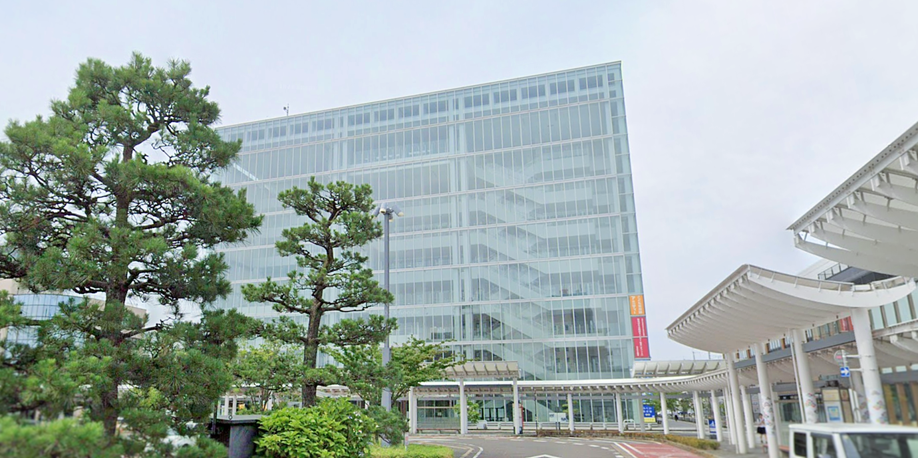
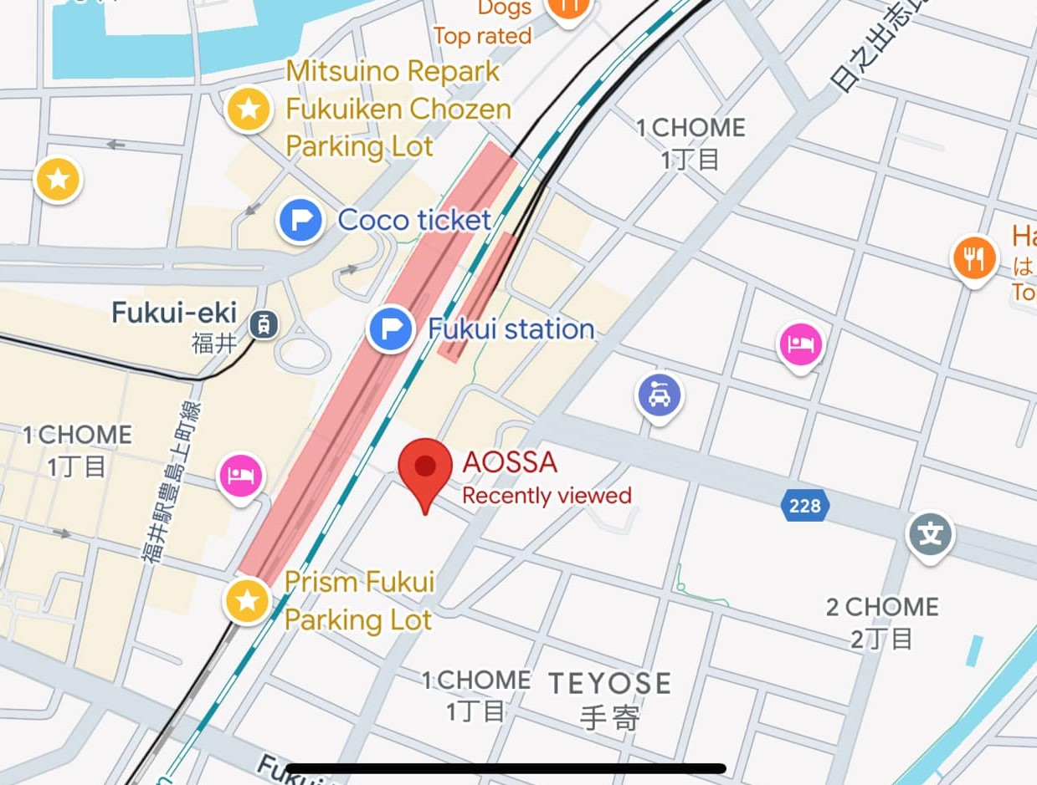
For example, EM2025_Fukui_Taro.pdf

Fig. 1. A photograph of the EM-NANO 2025 venue AOSSA building (left), and map around its vicinity (right).

References
  - T. Fukui, I. Ishikawa, S. Toyama, M. Nagano, N. Niigata, and E. M. Nano: Jpn. J. Appl. Phys. 10, 125 (2023).

